
DEPARTMENT OF COMMERCE
REPORT ON “Sustainnovate’ 25”

Date: 5th, 6th and 7th March 2025
Venue: AB2 3rd Floor, AB4 Auditorium
Timings: 9:00 AM to 4:30 PM
SUSTAINNOVATE 2025, organized by the Department of Commerce, Manipal Academy of Higher Education (MAHE), Bengaluru, was successfully held on the 6th and 7th of March 2025. This flagship event served as a platform for students to engage in business challenges, cultural expressions, and sports activities, fostering creativity, strategic thinking, and teamwork.
The event featured three key segments:
- Business Battles, where participants competed in Marketing, Finance, HR, Best Manager, and Business Plan Development, demonstrating their industry acumen.
- Cultural Extravaganza, showcasing talent through Dance Shows and Fashion Walks, promoting artistic expression and inclusivity.
- Games & Sports, including Mobile Gaming and Football Tournaments, emphasizing teamwork and competitive spirit.
With a total of 62 team registrations and 377 student participants from 21 colleges, the event witnessed enthusiastic engagement. Students' active participation and coordination contributed significantly to its success, particularly Ojas Khobe and Krittyka Chatterjee (Student Council Members). The theme SUSTAINNOVATE’25 effectively aligned with the United Nations Sustainable Development Goals—SDG 4 (Quality Education) and SDG 12 (Responsible Consumption and Production).

Key Highlights of the Event –
Day 1 – 6th March 2025
- Registrations (8:30 AM – 10:00 AM)
  - Participants arrived and completed their registration at the AB2 Building – Reception Desk.
- Inaugural Ceremony (10:00 AM – 10:30 AM, AB4 Auditorium)
  - Introduction and welcome by Vidur (Student) and Sustiannovate’25 schedule and details by Krittyka (student) set the stage for an inspiring event.
- Tea Break & Event Assembling (10:30 AM – 11:00 AM)
  - Participants were guided to their respective event venues.
- Competition Round 1 (11:00 AM – 12:00 PM)
  - Simultaneous rounds across five business competitions:
    - Finance (Room 310)
    - HR (Room 311)
    - Marketing (Room 312)
    - Business Plan (Room 313)
    - Best Manager (Room 314)
    - Gaming (Room 315)
- Campus Tour (12:00 PM – 12:30 PM)
  - A brief break to explore the campus.
- Lunch Break (12:30 PM – 1:30 PM)
  - Meals are provided at the AB4 Cafeteria by Chef’s Touch.
- Competition Round 2 (1:30 PM – 2:30 PM)
  - Participants advanced to the second round in their respective categories.
- Cultural Extravaganza (2:45 PM – 4:30 PM, AB4 Auditorium)
  - A vibrant showcase featuring dance performances and a fashion show.

Day 2 – 7th March 2025
- Reporting Time (8:30 AM)
- Competition Round 3 (9:00 AM – 10:00 AM)
  - Participants continued to showcase their skills in the business and gaming events.
- Tea Break (10:00 AM – 10:30 AM)
- Competition Round 4 (10:30 AM – 12:00 PM)
  - The final round across all business categories.
- Feedback Session (12:00 PM – 12:20 PM, Respective Classrooms)
  - Participants shared their experiences and insights.
- Lunch Break (12:20 PM – 1:20 PM)
- U25 Summit (1:30 PM – 3:30 PM, AB4 Auditorium)
  - Engaging sessions including:
    - Vibe Check & Warm-up
    - Student Talent Show
    - Introduction to U25
    - Entrepreneur Talk
    - Stand-up Comedy
    - Live Music Performance by Ashmit and Harshini
- Valedictory Ceremony (3:30 PM – 4:30 PM, AB4 Auditorium)
The Valedictory Ceremony commenced with a welcome address by Vibha (Student), followed by a summary of SUSTAINNOVATE 2025 presented by Dr. Urmila (Faculty Coordinator). Presidential speeches were delivered by Dr. Santosh (Head of Department) and Dr. Raghavendra Prabhu (Deputy Registrar), emphasizing the event's impact. The ceremony concluded with the prize distribution, celebrating the achievements and contributions of participants

Session Feedback –

- Overall Experience: The majority of the participants found that the overall experience at Sustainnovate’25 was excellent with an average rating of 4.52/5 from a total responses of 54 students. Additionally, same respondents also rated their particular event (the event in which they participated a 4.57/5 rating!
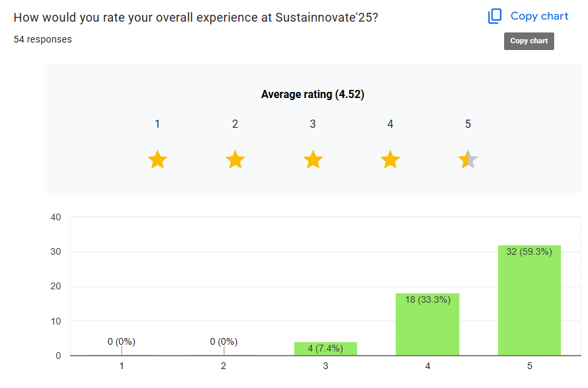
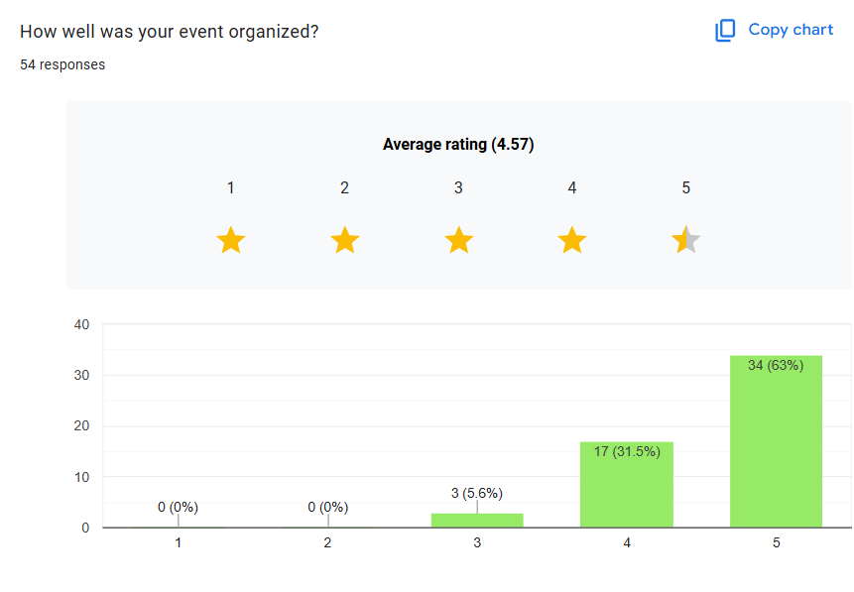
- Venue and Facilities: Students were happy with the hospitality they were being provided with here at the campus. Participants were completely satisfied with the venue of the events as well the campus in general.
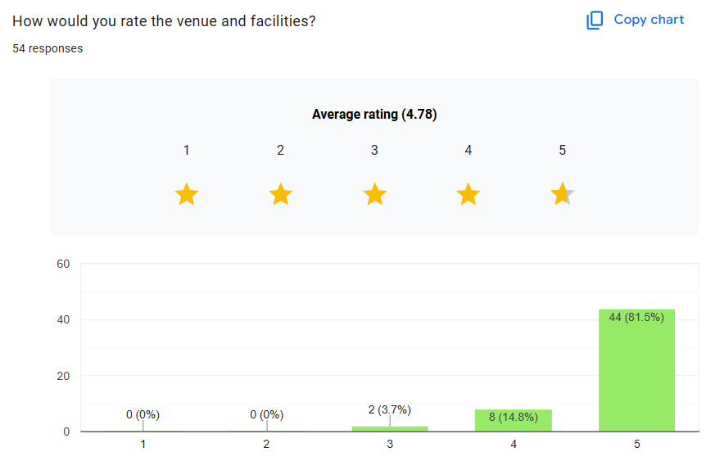
- Areas for Improvement: As answered by 28 participants in the Feedback form, the major feedback consisted of different areas with one of them being as to how can we improve on the designing of the rounds and others were in general as to Buggies were not provided for travel on the second day of the event.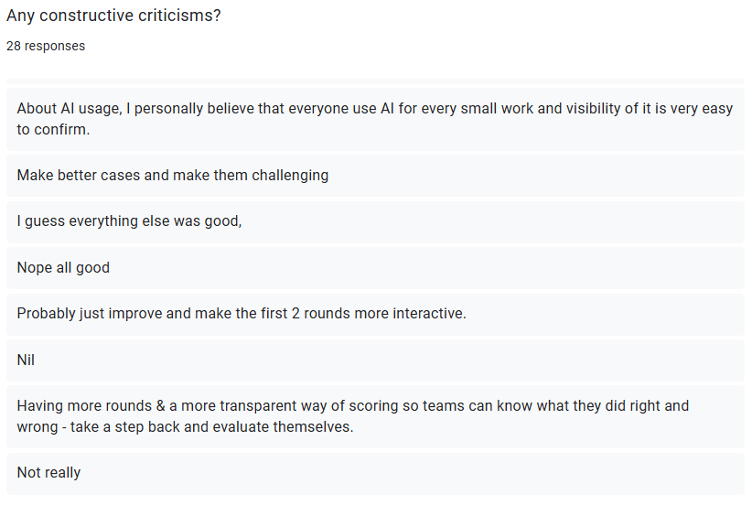
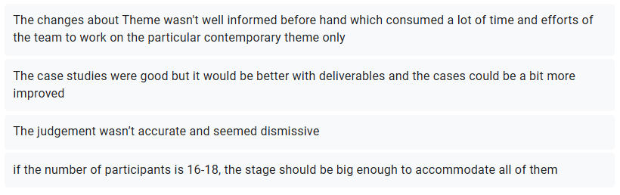

Brochure Attached

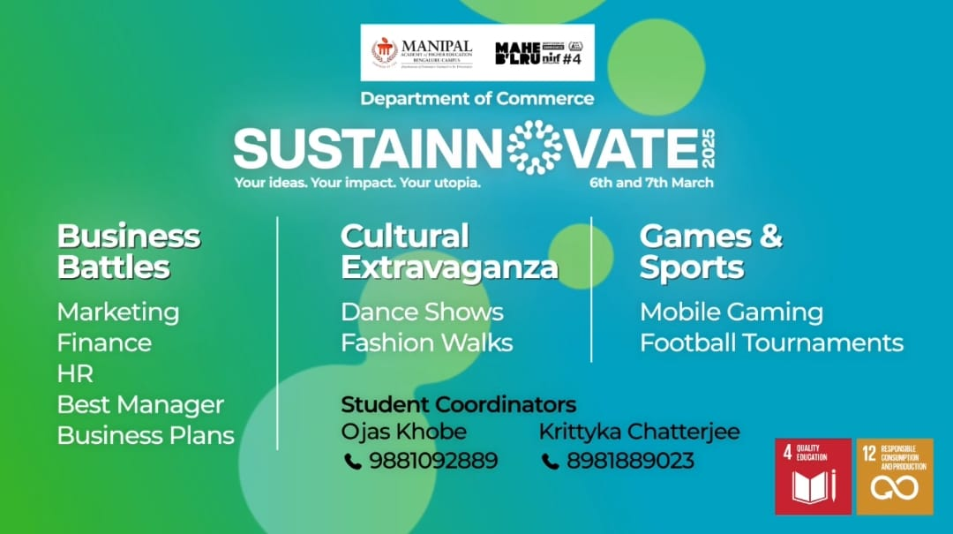

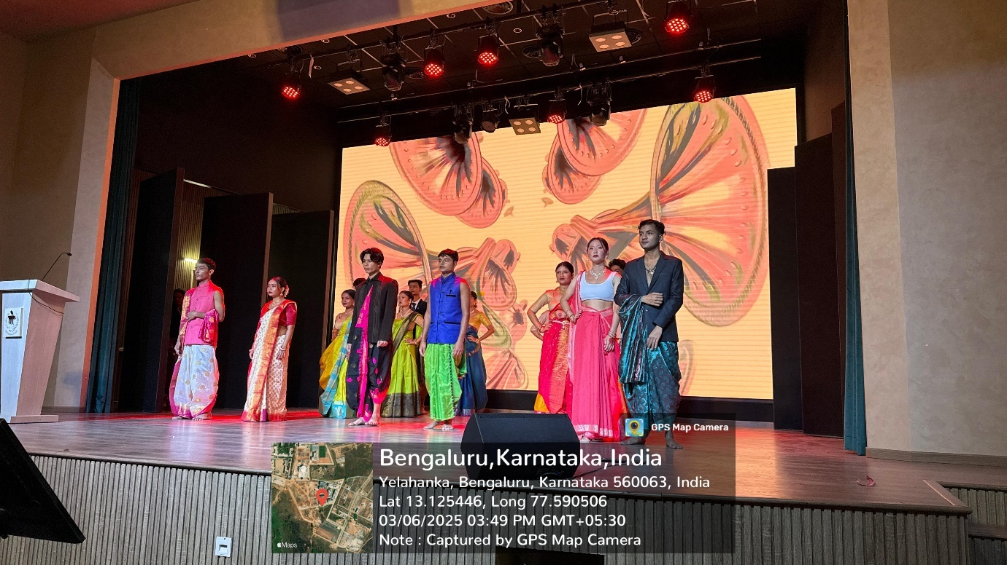

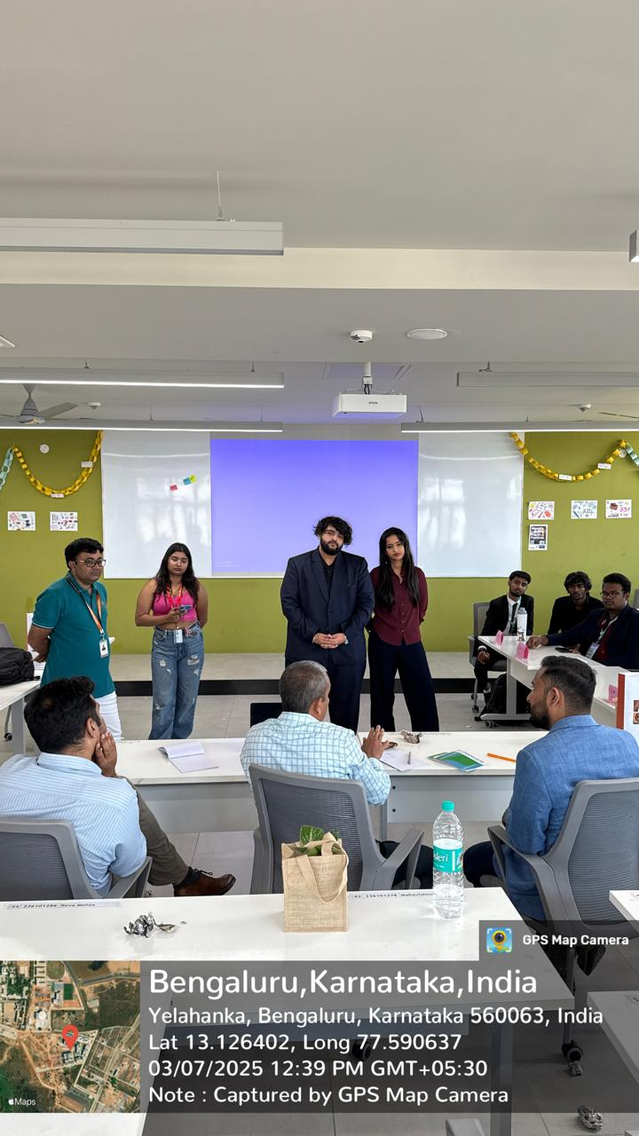
Attendance Sheet

Drive links for individual reports:
Best Manager – https://drive.google.com/file/d/1l_4xKFePNuJh3sgRifC5H6ACUX81xdz1/view?usp=sharing
Finance – https://drive.google.com/file/d/1eFF1N1AbFJ_0zrcAQ9QXP2qE3NFh-MhQ/view?usp=sharing
Marketing - https://drive.google.com/file/d/1eFF1N1AbFJ_0zrcAQ9QXP2qE3NFh-MhQ/view?usp=sharing
HR - https://drive.google.com/file/d/1PlSbqwFYPtTQxvbgmaDLzyHqXWlvPKex/view?usp=sharing
Business Plan - https://drive.google.com/file/d/1zuG66TVibVlKko_36sZfXBl_dPwHCQEJ/view?usp=sharing
Mobile Gaming – https://drive.google.com/file/d/1QQaT2hbHADijFDEKIJhcaUlupRXja5h2/view?usp=sharing
Football – https://drive.google.com/file/d/14zouLhEXg0IYKZEzvsqD3ZBb5qNEPl4P/view?usp=sharing
Group Dance - https://drive.google.com/file/d/1jwwvzzBEwbWHMkUekf6fqc-52hA1Y53J/view?usp=sharing
Fashion Show - https://drive.google.com/file/d/1V07OUSOYA_nEbB-eHeqfyDsc_U0aYCup/view?usp=sharing

Dr. Urmila Itam & Dr Shylaja H N Dr. B R Santosh
Event Co-Ordinator Head of the Department

